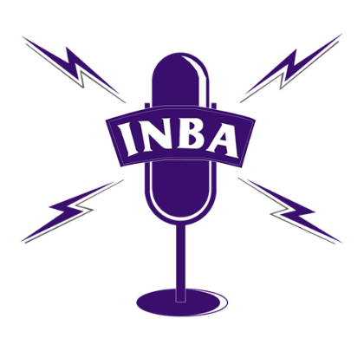

To the University of Illinois,

The Illinois News Broadcasters Association stands in solidarity with the journalists at NPR Illinois. We ask that you allow them to work independently and freely as journalists. We believe the journalists should be exempt from your policy requiring university employees to report instances of sexual assault or misconduct they’ve learned about to the school’s Title IX office.

As our attorney, Don Craven, pointed out in an article last week, the university’s counseling employees are exempt from this rule for a legitimate public purpose. Craven said, “We want people to be as comfortable as possible talking to them and for many of the same reasons, we want people to be as comfortable as possible talking to reporters in confidence.”

While your policy is intended to maintain safety on campus, a journalist’s job is to speak the truth, demand accountability, and give a voice to the voiceless. Victims of sexual assault or misconduct should expect to speak to journalists in confidence so journalists can accurately report on the effectiveness of safety systems in place.

In addition, the University of Illinois is a public university and holds the license for the public radio station. We hope the university would not hinder anyone’s choice to share their story with the public. By forcing journalists to adhere to your policy, you are taking away First Amendment rights not just from journalists, but from victims too. It should be the victim’s choice whether to share his or her story and journalists should be free to publicize those stories as they see fit.

The INBA requests that you provide exemptions for journalists in your policy. We thank you for your time and consideration.

Respectfully,

The Illinois News Broadcasters Association – Board of Directors

Josh Morgan, President
Brian Moline, Vice President
Tanya Koonce Williams, Treasurer
Rich Egger, Executive Secretary
Rachel Lippmann, Recording Secretary
Laura Trendle-Polus
Rick Koshko
Molly Jirasek
Ryan Denham
Mike Miletich
Margaret Larkin
Dana Vollmer
Sam Dunklau
H Wayne Wilson

